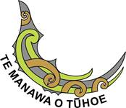

TE MANAWA o TŪHOE
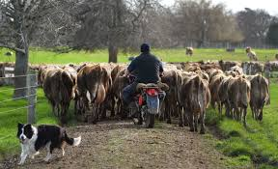
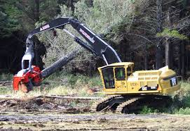
CONTRACTOR HEALTH AND SAFETY INDUCTION

“We are committed to ensuring that everyone goes home safe and well at the end of every working day”.
This Induction Manual outlines the Essential Health, Safety and Environmental information for the Te Manawa o Tūhoe Trust including the Hatupere Farm, the Paekoa Farm Support Unit and the Forestry.

(NOTE: When answering the questions please circle/mark the correct answer)

1. Which of the following statements is correct?
- TMOT is committed to ensuring everyone goes home on time and quickly at the end of every working day
- TMOT is committed to ensuring everyone goes home stressed and tired at the end of every working day
- TMOT is committed to ensuring everyone goes home safe and well at the end of every working day

TMOT H&S Induction - February 2022

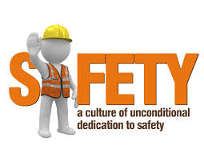
ACCIDENTS ARE PREVENTABLE
Our Vision & Commitment is to ensure the Health and Safety of every Worker (employee, contractor and visitor) to TMOT workplaces, to ensuring healthy and safe working conditions and the safe operation of all equipment.
We actively encourage the participation of workers and will work with you to make continuous improvements to achieve a HARM FREE WORKPLACE.
TEN SIMPLE WAYS TO ENSURE YOUR SAFETY AND ZERO HARM ON OUR WORK SITES
TAKE THE TIME TO:
- Understand the Skope of Work (“what does the job entail”)
- Identify the Hazards
- Put in Place the Correct Control Measures.
- Plan the Emergency Procedures.
- Continually Monitor the Work Process & Re-evaluate the Risks
- Take Responsibility for Your Own Safety and that of Your Fellow Workers.
- STOP WORK IMMEDIATELY if you are unsure or uncomfortable about any Serious Safety Related Concerns
- Seek help and advice from the onsite Manager / Person in Charge as appropriate.
- Report ALL Injuries, Incidents, Near Misses and Hazards
- All work must be carried out to the Highest Industry Best Practice Standards for Health, Safety, Environment and Quality

Working Safely and Responsibly is a key condition of Employment on our Sites. This induction is an overview of the Health and Safety standards we require and expect.
Equipment and Machinery can be replaced – but people cannot.
You are our most precious asset so please follow all Safety Requirements and look after one another.

PLEASE NOTE: A SITE-SPECIFIC INDUCTION WILL BE REQUIRED FOR THE TMOT BUSINESS UNIT YOU VISIT OR ARE EMPLOYED AT.
- Simple ways to Ensure your Safety & Zero Harm on our Work Sites are?
- Understanding the Scope of Work
- Identifying the Hazards
- Have in place the Correct Control Measures
- Emergency Procedure Plan
- Take Responsibility for Your Own Safety first.
- All of the above

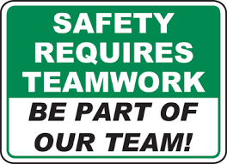
COMMITMENT TO HEALTH & SAFETY ON
TMOT SITES
Our Commitment
- TMOT is Committed and takes full Responsibility to:
- Ensure the Health & Safety of all Workers including all of our Contractors.
- Set Health & Safety objectives & performance criteria.
- Monitor, Review & Report on all aspects of Health & Safety within the organisation
- Ensure there is good communication on all H&S matters & that everyone has ready access to all relevant H & S information

Your Commitment
- All Workers/Contractors are:
- Expected to participate in all Health & Safety initiatives, policies & procedures
- Report all INJURIES, INCIDENTS & NEAR MISSES
- Attend all safety meetings, training etc. and observe & follow all safe work instructions & rules.
- Participate in the Company Health & Safety Initiatives.

- One of the key Commitments of all Workers is to report:
- When they have their meal break?
- Only serious accidents?
- All Injuries, Accidents, Incidents & Near Misses?

Health and Safety Committee & Plan
TMOT does have in place a Health & Safety Committee made up of representatives from management & workers from each Business Unit (Farming and Forestry)

THESE PEOPLE ARE YOUR REPRESENTATIVES – SUPPORT THEM.

WE ENCOURAGE YOUR FEED BACK, COMMENTS, CONCERNS & ANY GOOD IDEAS TO IMPROVE HEALTH & SAFETY

ACCESS TO TE MANAWA O TUHOE WORK SITES
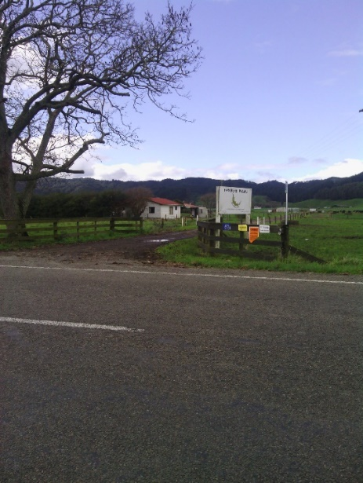

Te Manawa o Tūhoe will ensure that we apply the same Duty of Care and Health and Safety obligations to Contractors and Visitors as we would for our own Workers as required by the Health and Safety at Work Act 2015.
Everyone entering onto a TMOT Site whether it is the Farms or the Forest MUST:
- Have completed the TMOT Induction and Questionnaire.
- Have evidence of a current TMOT Induction. (A Certificate/Card will be provided)
- The Induction will expire after two (2) years and you will then be required to complete the Induction Process again.
- Everyone entering a TMOT Site MUST have completed:
  - A thorough cleaning of your vehicle?
  - The TMOT Induction and Questionnaire?
  - A Worksafe H&S briefing?

- You MUST Notify and have the Prior Approval of the BU Manager/Crew Boss, GM or H&S Manager before entering a TMOT Site and must sign the VISITORS LOG on arrival.

NO ONE IS TO ENTER A FORESTRY ROAD or SITE without TMOT or the Forest Managers (PF Olsen/Hancock’s) approval and:
- Displaying the appropriate Notices/windscreen stickers.
- Had the appropriate Induction, Training & Familiarisation.
- Before entering a TMOT Site all Workers, Contractors & Visitors MUST:
  - Notify the TMOT Business Unit Manager/Crew Boss?
  - Have Prior Approval?
  - Sign the Visitors Log Book on arrival?
  - All of the above?
- Carrying a Fire Extinguisher, First Aid Kit and Shovel
- Headlights on & following all the Forestry Safety Rules.
- Having the required Radio Communications with appropriate RT Channels & calling markers as required.
- If you are not authorised and/or permitted you will be met at the gate and either escorted or transported onto the site.
Contractor Obligations:
- All Contractors MUST COMPLY with all TMOT H&S policies and procedures, the Health and Safety at Work Act 2015 and all other relevant Act’s, Regulations and Approved Codes of Practice
- You will be required to undertake a site-specific induction to high-light the local hazards, ‘no-go’ areas, safe retreat zones, emergency procedures etc.
- You will be escorted at all times unless you are appropriately trained, qualified, competent and authorised to move about the site independently.
- You MUST wear the appropriate AS/NZS (or EN) approved standard PPE (Personal Protective Equipment) at all times.
- The minimum PPE requirement for Visitors to any Forestry Site is an approved (fluorescent) Safety Helmet, a safety Hi-Viz jerkin (day/night) and Safety Boots.
- The minimum PPE requirement for Visitors to any other TMOT operational site (farms etc.) is an approved safety Hi-Viz jerkin (day/night) and Safety Boots.
- Hearing and eye protection must be worn when the relevant hazard exists.
- All INJURIES, INCIDENTS and HAZARDS must be reported.
TMOT Obligations:
When any Contractor or Visitor arrives on any of our sites we WILL:
- Stop any operations that may put you the contractor/visitor at risk.
- Acknowledge and meet with you.
- Ensure that you sign the visitor’s book and that you have the appropriate PPE
- If necessary, you will be escorted onto and around the site as required.
- We will advise our Manager / Crew Boss that a visitor has arrived
- We will ensure that all of the requirements, rules and actions as set out above are followed and understood by you.
NOTE:
All Contractor Principles MUST Complete a separate Contractors Induction Process that includes:
  - The provision of, and evidence of H&S Plans, Policies & Processes and Safety Meetings
  - Hazard Management Procedure.
  - Appropriate PPE
  - Certification of equipment

QUALIFICATION, TRAINING & COMPETENCY
- All Contractors/Workers MUST have evidence that they are appropriately Qualified, Trained and Competent to carry out the tasks/jobs required of them Safely & to the required Standards
- This includes all vehicles, mobile plane and equipment.
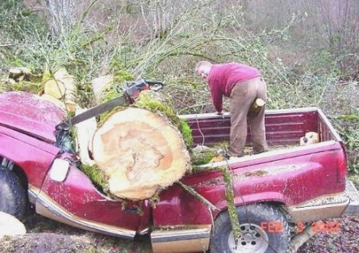
- TMOT may ask to see training records/qualifications especially if the work is considered high risk.
Operating plant or machinery or carrying out tasks that you are not trained for is considered a Serious Breach of the Safety Rules.

TOOLBOX (TAILGATE) & MONTHLY SAFETY MEETINGS AND SAFETY BULLETINS & NOTICES

Tool Box Meetings
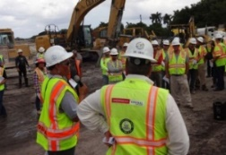
Everyone MUST attend a Toolbox/Tailgate meeting before starting work each day or work period.
These are very important as they not only outline the key tasks for the day and other useful information but they also provide a timely reminder of the hazards and vital safety aspects of the job ahead.

Safety Meetings
Our TMOT Business Units hold regular meetings as deemed necessary
We strongly encourage and expect contractors to attend these meetings if they are on any of our sites when these meetings are held

“We all learn something new every day and you never know you might learn something that saves you or your mates from suffering a serious injury”.

Safety Bulletins & Notices
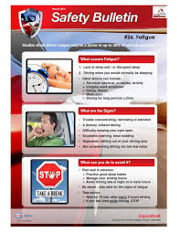
From time-to-time Safety Bulletins & Notices will be distributed both from within the organisation and from Work Safe NZ & other Industry Organisations.
Please ensure you read these as they provide vital and important information on events, incidents, change in legislation etc. that we can learn from to help keep us safe and focussed on our health and wellbeing.
PERSONAL PROTECTIVE EQUIPMENT
Personal Protective Equipment (PPE) appropriate for the task/job MUST be worn at all times on Te Manawa o Tūhoe Sites.
- All PPE must meet or exceed the relevant AS/NZS Standards
- The PPE must be kept in a clean and good safe condition at all times.
Forestry Workers MUST wear the following PPE at all times:
  - Day/night hi-vis vests (or other coats, jackets, etc. that meet the required standard)
  - Heavy duty forestry safety foot-wear when operating chainsaws
  - Fallers and breaker outs Must wear spiked boots (Not to worn while driving)
  - Safety Helmet.
  - Hearing Protection as required
  - Chainsaw Operators MUST wear Safety Helmet & Visor, appropriate Safety Boots, Ear Protection (Level 5), Chaps and Safety Glasses where hazards exist.
  - Any other PPE Appropriate for the task

Farm Workers MUST wear PPE appropriate for the task including the following:
  - Suitable PPE to protect from bio-hazards associated with handling cattle and other farm animals and associated equipment
  - Safety footwear (work boots/gumboots) where there is any risk of a foot crush/injury.
  - Day/night hi-vis vests (or clothing) when working around moving vehicles and mobile plant.
  - Appropriate face masks, eye protection, gloves, overalls etc. when handling chemicals/spraying etc.
  - The appropriate PPE when using chainsaws and other powered hand tools such as scrub cutters
Failure to comply with PPE requirements will result in disciplinary action being taken that may include removal from the site.
If you are not sure what P.P.E. you should wear – ASK
- If you fail to wear your P.P.E. what action may be taken?
- You will be warned and given the rest of the day off on pay.
- You will be sacked immediately
- Disciplinary Action

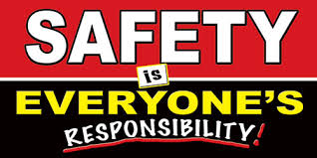
HAZARD MANAGEMENT
The direct and potential Hazards of each job MUST be Identified and Communicated to every worker on TMOT sites before work starts.
Appropriate Control Measures MUST be put in place to PROTECT People and the Environment from HARM.
Every contractor / worker including our own TMOT Management, Crew boss and workers are responsible for the following:
- Starting with Good Planning is Essential
- Ensuring that the detail and scope of all Tasks/Jobs are identified.
- Ensure that everyone working on the Site is Appropriately TRAINED and COMPETENT to do the Task/Job SAFELY
- That all Hazards are Identified, Control Measures are in place and the details are Recorded and Communicated to all workers before work starts.
- Where the Hazard Register doesn’t cover the work or tasks being carried out a JSA (Job Safety Analysis) MUST be completed and the Hazard Register updated as required.
- To confirm the Risk Level – use the RISK SCORE CALCULATOR
- Everyone working on the task/job should sign onto the JSA.
- Regularly review your job and work processes for any new or introduced Hazards and update your control measures accordingly.

ELIMINATE – MINIMISE.

BASIC HAZARDS ON TMOT SITES
Hazards on Te Manawa o Tūhoe Sites are many and varied and before any job or task is started Check with the specific Business Unit Manager / Crew Boss and the BU HAZARD REGISTER.
Some of the Hazards you may find on TMOT Sites include (but are not limited to) the following:
- Slips, trips and falls.
- Manual Handling
- Powered Hand Tools & Equipment
- Over-head obstructions & objects falling from height.
- Moving vehicles, mobile plant & machinery.
- Chemicals / Hazardous Substances, Fuel, Oil, Fueling Operations
- Fatique
- Working in Extreme Conditions – Hot, Cold, Wet
- Noise,
- Discomfort Pain Injury (DPI)
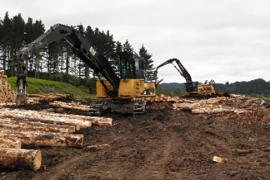
Forest Operations - Tree Felling, Breaking Out, Chainsaws, Cable Harvesting, Wire Ropes, Tree Driving, Hang Ups, Safety Zones, Safe Retreat Areas – “Two Tree Lengths”, Log Processors, “Chain Shot”, Skid Work, Forest Fires, Forest Roads, Dust, DPI (OOS)
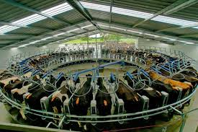
Farming Operations – Dairy Sheds, Cattle Handling, Farm Tractors & Machinery, Effluent Ponds/Systems, Bio Hazards, Animal Diseases, Races, Bridges & Culverts, Electric Fences, Chainsaws, Post Rammers, Quad & Motor Bikes, Gas Pipe Line (Hatupere/Forest)

Hazard Identification is the Key Element for a Safe Working Environment
- There a multiple Hazards found on TMOT Sites - please circle the one that does NOT apply?
  - Slips, trips and falls
  - Moving vehicles, plant and machinery
  - Explosives
  - Chemicals / Hazardous Substances
  - Effluent Ponds

TE MANAWA O TŪHOE – HATUPERE FARM MAP
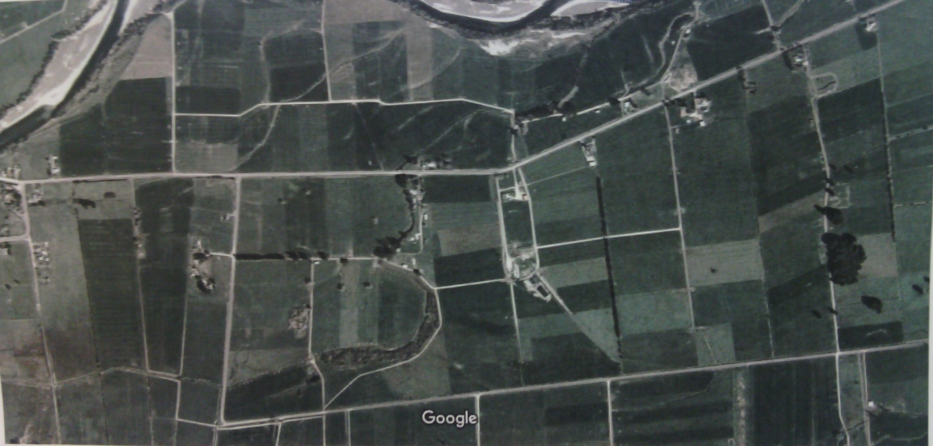
LOCATIONS AND MAJOR HAZARDS
Main Farm House
Bridges/Culverts with Weight Restrictions
Emergency Assembly Area
Under Ground Power & Internet Cables
Reid Rd
Cow Shed
Effluent Pond
PRIVATE
LAND
Awahou Rd
Vector - Main Gas Transmission Pipe Line
Villa
Under Pass
Effluent Ponds

TE MANAWA O TŪHOE – PAEKOA DSU MAP
LOCATIONS AND MAJOR HAZARDS
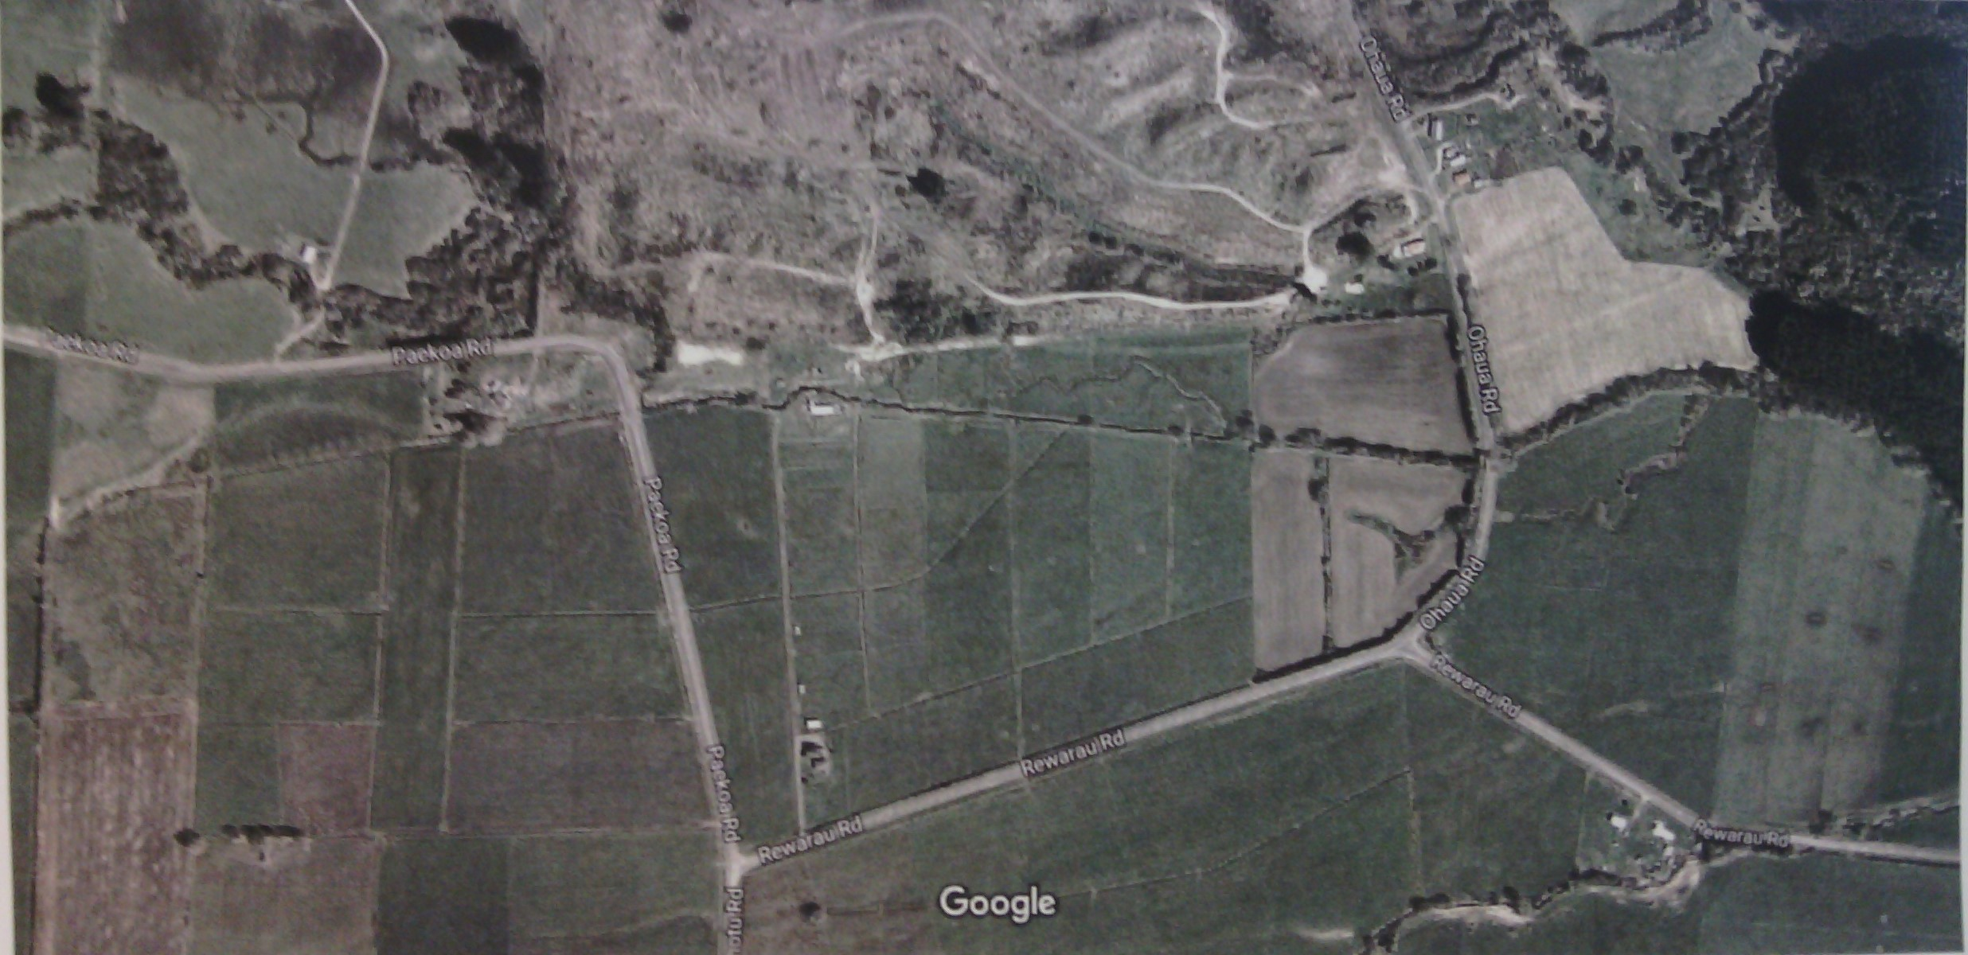
Narrow Culverts
Old Cow Shed
Emergency Assembly Area
Paekoa Rd
Main Farm House (Sign In / First Aid)
Rewarau Rd

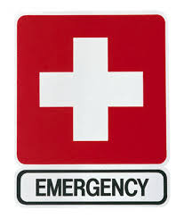
EMERGENCIES
IF YOU ARE INVOLVED IN A SERIOUS EMERGENCY – accident, injury, medical illness or fire:
CALL EMERGENCY SERVICES ON 111 or if you are in the Forest you can call RADIO HEADQUARTERS on CHANNEL 21.
- STOP WORK IMMEDIATELY and MAKE SURE THE AREA IS SAFE.
- ENSURE YOUR OWN SAFETY FIRST - isolate power supplies and other energy sources from plant and machinery, lower raised equipment etc.
- All TMOT Business Units have First Aid Kits & Qualified First Aiders -
  - Administer First Aid/Medical assistance as necessary and carry out rescue if required
  - For other emergencies such as Fires and Chemical spills etc. - if you are trained and competent take the necessary action to minimise the escalation of the incident.

- If you are involved in a Serious Emergency, you MUST? (please circle the one that does NOT apply)
- Tell your work mate and continue to work only if you are not hurt?
- Stop Work Immediately?
- Make Sure the Area is Safe?
- Ensure your own Safety First?

- If you suspect the incident is a Notifiable Event (Serious Harm) every effort must be made to protect the scene and all evidence. The scene MUST be frozen/secured until such time an investigation is completed and it is cleared by Work Safe NZ.
- If possible, take photos of the scene/incident.
- The GM and/or the Health & Safety Officer MUST be called immediately
- Prepare the scene for the Emergency Services –
  - Have someone available at the main road/gate to give directions.
  - If necessary, set up a helicopter landing site.
- If you suspect the incident is a Notifiable Event (Serious Harm) every effort is to be made to Protect the Scene and all Evidence.
TRUE or FALSE?
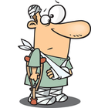
All Injuries, Incidents, Accidents and Near Misses MUST BE REPORTED and INVESTIGATED.

ACCIDENT, INJURY, NEAR MISS and MINOR INCIDENT REPORTING
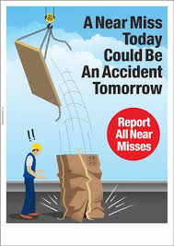
INJURY and SERIOUS INCIDENT REPORTING
After the accident scene is Secured, made Safe and any Injuries dealt with, the key requirements are:
- Report the incident immediately to your Manager or Supervisor and our TMOT Business Unit (BU) Manager, Supervisor or Crew Boss as appropriate.
- If an injured person is required to go to a Doctor, A & E and/or the Hospital then they MUST be accompanied by another crew member/fellow worker.
- In such cases the GM and/or the Health & Safety Manager must be contacted as soon as practical.
- Remember that if there is a Notifiable Event whether Injury, Illness or incident (Serious Harm) avoid disturbing the scene, close down and “freeze” the scene until such time as it is cleared by the Work Safe NZ Inspector.
- A full Investigation and Accident Report MUST be completed.
- In the case of serious Notifiable Injuries or illness events (Serious Harm) – Work Safe NZ MUST be NOTIFIED “as soon as possible”.
- The notification should only be done by the CEO, the H&S Manager or with their approval.
- You may be required to assist in any investigation so please cooperate fully – thanks.
NEAR MISS REPORTING
- A Near Miss (or Notifiable Incident) is defined as – something that happens that you believe could have caused harm to you or a fellow worker &/or the environment.
- Every time a Near Miss is identified it MUST be REPORTED – no matter how large or small, where it is or who was carrying out the task/job.
- Complete the Near Miss Form or if you wish you can phone, email or text.

Our focus is on DEALING with the FACTS and LEARNING from the event – reporting a Near Miss could help prevent similar incidents re-occurring in the future
Failure to report any Near Miss, Injury or Incident at any TMOT Site – will be treated as Serious Misconduct
- You only have to Report Near Misses & Minor Incidents if you:
- Hurt yourself?
- Every time a Near Miss/Minor Incident is identified no matter how large or small?
- If someone else witnesses the event?
- If time permits?

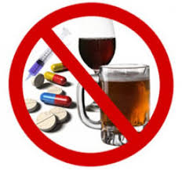
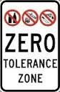
DRUGS & ALCOHOL
Te Manawa o Tūhoe has in place a Drug and Alcohol Policy.
Drugs and Alcohol are STRICTLY PROHIBITED on all TMOT Sites, Buildings, Vehicles etc.
- All Workers, Contractors and Visitors at all levels are prohibited from working or conducting Company business under the influence of drugs or alcohol.
- You MUST NOT operate Company plant, vehicles, machinery or equipment having used drugs or alcohol.
- Contractors / workers taking any medication (whether prescription or over the counter) must ask their medical practitioner (such as their doctor or pharmacist) whether such medication creates a risk of impairment in the performance of their duties. If the medication creates such a risk, the worker/contractor MUST disclose this to the Manager/Crew Boss before starting work. You will either be stood down or if appropriate offered alternative duties where there is no risk to yourself or fellow workers.
- If you are found to be under the influence of alcohol or any illegal substance and fail a Drug and/or Alcohol test you will be stood down immediately, you will be required to undergo further testing and disciplinary action will be taken.
- Post incident drug and alcohol testing will be carried out after all accidents or incidents and reasonable cause testing will be carried where it appears that someone is under the influence of drugs and/or alcohol due to their actions, behaviours or conduct.
- Random drug and alcohol testing will be carried out from time to time especially in high-risk areas and/or for “safety sensitive” employees/workers
- Drug and alcohol testing will be carried out where there are cases of serious misconduct and disciplinary procedures
- The Company supports an Employee Assistance Programme (EAP) and voluntary rehabilitation programme and may provide some funding.
- Regular education, information and training will be provided.
(Please Note: This is only a brief summary of our Drug and Alcohol Policy – a full copy of the D&A Policy can be provided on request)
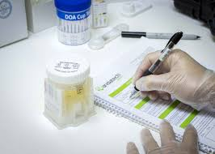
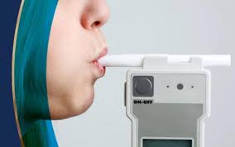
Failure to participate in a Drug & Alcohol Test will be treated as Serious Misconduct.

- Which of the following statements in INCORRECT?
Drug & Alcohol testing may be carried out:
  - If there is Reasonable Cause?
  - Randomly?
  - When you are home on the weekend?
  - Post incident/accident?
GENERAL SAFETY REQUIREMENTS
VEHICLES & MOBILE PLANT ON TMOT SITES.
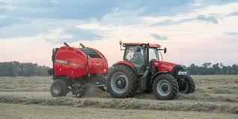
Everyone driving Vehicles or operating Mobile Plant on TMOT Sites MUST have the APPROPRIATE LICENCES and training/competencies.
- All NZ Traffic and Worksafe Regulations & Rules apply at all times
- Seat belts (where fitted) MUST be worn at all times regardless of the location and speed.
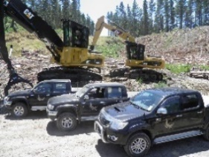
- Spiked boots are BANNED when driving vehicles or operating Mobile Plant
- When driving/operating vehicles & mobile plant in Forests you:
  - MUST adhere to all Forestry and TMOT rules and signage at all times – lights on.
  - Vehicles MUST be parked in the designated Safe Area, facing out & keys left in the ignition
- If your machine or tractor is fitted with seat belts, are you required to wear when operating on a private road or property? Y / N (Circle)

- Anyone working or entering areas where there are vehicles, mobile plant, machinery & equipment operating MUST wear day/night HI-VIS clothing.
- It is your responsibility to manage &/or report Fatigue / Discomfort Pain Injury (DPI / OOS)

- When working in areas where vehicles & mobile plant are operating what essential PPE Must you wear?
- Long trousers?
- Hi-Vis Clothing?
- Sun hat?
- Gum-boots?
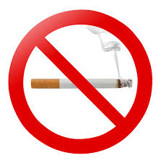

SMOKING RESTRICTIONS
Smoking is BANNED inside and around all TMOT buildings, houses, vehicles, mobile plant and offices whether owned or leased by the Company/Trust.
Everyone (workers, contractors and visitors may only smoke in designated external areas. If there is no specific designated smoking area, then you MUST leave the site if you wish to smoke.
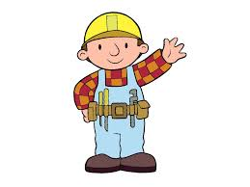
TOOLS & EQUIPMENT
- All equipment must be in good Safe Working Condition & fit for purpose
- All electrical leads, tools & appliances MUST have a current Electrical Tag.
- Ensure leads, hoses, equipment & tools do not create a trip hazard for others
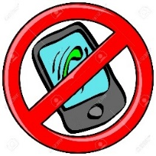
MOBILE PHONES
The use of Mobile Phones and other electronic devices is BANNED IN ALL OPERATIONAL AREAS. This includes in all Vehicles, Mobile Plant, Machinery, On & Around Skids, Tree Felling, Farming Operations etc.
The Exceptions are:
- Crew Bosses/Managers who require cell phones for work purposes/emergencies etc.
- Other Approved & Designated workers who require mobile phone communication for work purposes
- In Smoko Rooms/Containers / Non-Work Areas, at meal breaks &/or outside of work time.

FAILURE TO ADHERE TO THESE RULES WILL RESULT IN DISCIPLINARY ACTION BEING TAKEN.

- Mobile Phones and other electronic devices are Banned in All TMOT Operational TRUE or FALSE?

MANUAL HANDLING

Poor Manual Handling of Tools & Equipment is recognised as one of the most common causes of Workplace Injuries.

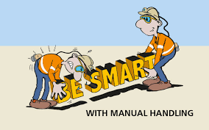
- Plan your work
- Use correct lifting methods
- Seek help when needed – share the load.
- Use appropriate lifting equipment where possible
- Wear gloves to protect hands & fingers.
- Remove/eliminate sharp edges, spikes, sprags etc.

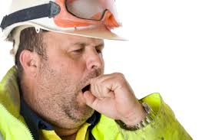
FATIGUE
Tiredness and fatigue issues can contribute too or cause serious accidents.
Manage work time and rest time responsibly to avoid fatigue – the general guidelines are no more than 13 hours in a 24hour period with a 10hour break and a maximum of 70 hours in any working week and then a minimum of a 24hour break.
Other contributing factors to fatigue are:
- Nature of the job
- Heat/Cold/Wet conditions
- Distance travelled to & from home
- Level of Fitness
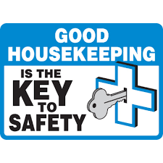
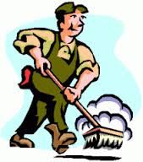
HOUSEKEEPING

Good Housekeeping is essential to a Safe Work Place and the Prevention of Pollution.
- Keep all Work Areas clean and tidy and clear of waste material, debris, unused equipment etc. – keep a check for trip hazards.
- Ensure access ways, roads, escape routes are kept clear at all times.
- When not in use store all tools, plant, equipment and material in a safe designated area.
- Tidy and clean work area on a regular basis.
- Dispose of waste material responsibly

CHEMICAL / HAZARDOUS SUBSTANCES
There are numerous types and quantities of Chemicals/Hazardous Substances stored and used on TMOT sites.
- Any chemicals brought onto TMOT sites MUST be APPROVED, have MSDS (Material Safety Data Sheets) and have a SAFETY MANAGEMENT PLAN / EMERGENCY PROCEDURES in place - BEFORE they are brought onto site.
- All Chemicals must be correctly labelled, stored and tracked.
- The correct PPE must be available and used as appropriate.
- Workers MUST be correctly trained and qualified.
- The various TMOT Business Units have a record of their specific chemicals with MSDS sheets, and PPE available.
- All Chemicals MUST be disposed of in the correct & safe manner.
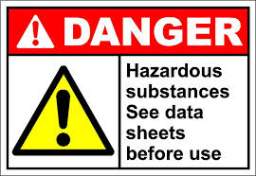
- What does the letters “MSDS” stand for?
- Machine Safety Device Standard?
- Micro Science Development Specialist?
- Material Safety Data Sheet?

CHEMICAL ACCIDENTS
In the event of a Hazardous Chemical Splash:
  - Use the nearest water supply (preferably running water) to immediately wash the affected area for at least 15 MINUTES.
  - If in eyes – wash thoroughly with Clean Water.
  - Remove contaminated clothing, foot wear etc.
  - Call for Medical Help as soon as possible.
  - Even if the incident appears minor you MUST ensure the person concerned has Medical Treatment.
  - If safe to do so, take the appropriate steps to control the spill

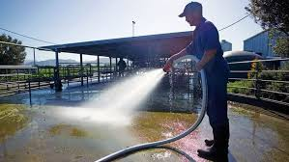
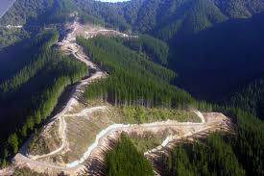
ENVIRONMENTAL
Care of the Environment is vital – we have a Legal and Moral responsibility to protect our environment for future generations.
Our Key Environmental Objectives are:
- Ensure that our Forestry, Farming, Logging and all other current &/or future operations:
  - Do not impact on the environment in any way – this includes waste-water, farm effluent, runoff, erosion, dust, noise, odour, chemicals, oils, fuel, hazardous substances etc.
  - Ensure all of our operations support a sustainable future.
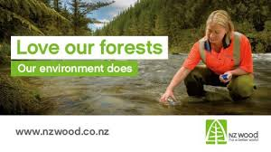
  - That we do NOT adversely affect Waahi tapu, historic, and other sites of cultural significance.
  - That we minimise the effects on fish & wildlife habitats and other natural resources.
  - That we monitor and review our Environmental performance

- Care for the Environment is vital
  - We are allowed to have some effluent runoff from the farm because in flows into a large river -TRUE or FALSE?
  - We only have to review & monitor our environmental performance if we have an Environmental Plan – TRUE or FALSE?
  - We have a Legal and Moral responsibility to protect our environment for future generations – TRUE or FALSE?
  - We must minimise the effects on fish and wildlife habitats – TRUE or FALSE?

WHAT CAN WE DO?
- Pre-plan and Control any potential wastes from our work operations – ensure Spill Kits and other means of Controlling Contamination are in place before work/operations begin.
- Dispose of all waste RESPONSIBLY in the Correct, Safe and Environmentally Friendly manner.
- DO NOT dispose of any waste (fuels, oils, chemicals, rubbish etc.) into rivers, creeks, waterways, land etc. or anywhere that is likely to impact on the environment.
- Report all spills, leaks, contamination IMMEDIATELY.
- If safe to do so Secure the Scene, Control leaks/spills and take the necessary actions to restrict the impact of the incident.
- Seek professional help to clean up & de-contaminate the affected area as required
- Take extra care and manage the use of fertilisers, chemicals, sprays, pesticides, herbicides and animal products.
- Good housekeeping is essential to a Safe Work Place & the Prevention of Pollution
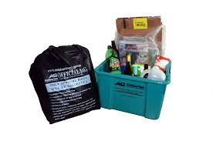
ALL CHEMICALS USED ON TMOT SITES MUST BE APPROVED FOR USE
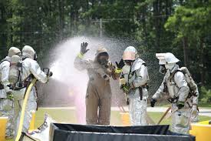

IF YOU ARE NOT SURE ABOUT SOMETHING – PLEASE ASK! **************************************************************************************
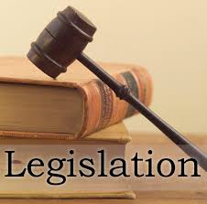
RELEVANT INDUSTRY LEGISLATION AND APPROVED CODES OF PRACTICE

Te Manawa o Tūhoe aims to meet or exceed the requirements of all Legislation, Regulations, Code of Practices and Industry Best Practices and this Presentation/Booklet includes the following:
- Health and Safety at Work Act 2015
- Health and Safety at Work General Risk & Management Regulations 2017
- Health and Safety at Work – Hazardous Substances Regulations 2017
TMOT - KEY CONTACTS
The Managers/Supervisors/Crew Bosses for each of the Business Units, currently: –
- Cameron Mitchell – Hatupere Farm (Ph. 021 2837087)
- Henry Rogers– Paekoa DSU (Ph. 0274 517736)
- Mike Christini – Acting GM and H&S Manager (Ph. 021 2233820)
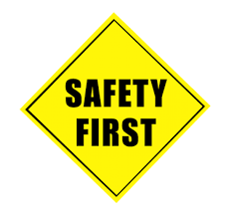
HEALTH & SAFETY SUMMARY

SIX SIMPLE WAYS TO HELP US ACHIEVE
ZERO HARM ON TMOT SITES

RECOGNISE – that all work accidents are avoidable.
PLAN JOBS CAREFULLY – using Hazard ID, JSA Risk Assessment and Effective Safety Control Measures
ELIMINATE – at Risk Behaviours and Encourage Safe Ones
ENSURE – your OWN SAFETY and that of your FELLOW WORKERS
COMMUNICATE – all health and safety matters promptly and effectively.
STOP WORK IMMEDIATELY – if there are any Serious Safety Concerns and seek help/report to a TMOT Manager/Crew Boss

IF IN DOUBT- ‘ASK’

- One of the ways to help us achieve Zero Harm on our Sites is to:
- Encourage full production even if there is a slight safety risk.
- Eliminate at Risk Behaviours and Encourage Safe Ones.
- Ensure the safety of plant and equipment first because it is expensive to replace.
